MADURAI KAMARAJ UNIVERSITY COLLEGE

MADURAI

SUBSCRIBERS GALORE : WORLD’S TOP YOUTUBE CHANNELS

1)**INTRODUCTION**

“Subscriber Galore: Exploring World’s Top YouTube Channels” is a YouTube series or website that delves into some of the most popular and influential YouTube channels from around the world. This show or platform provides in-depth reviews, analysis, and highlights of these channels, showcasing their content, creators, and the reasons behind their massive subscriber counts. It's a great resource for those looking to discover new content and understand the strategies that have made these channels so successful.

2)**PURPOSE**

Exploration and Discovery: It aims to help viewers discover new and popular YouTube channels from various genres and niches that they might not have come across otherwise.

**Analysis and Insights**: The show provides analysis and insights into what makes these top YouTube channels successful, including content strategies, audience engagement, and branding.

**Inspiration**: By showcasing the stories and journeys of successful YouTubers, it can inspire aspiring content creators to learn from their experiences and apply similar strategies to grow their own channels.

**Entertainment**: “Subscriber Galore” can also serve as an entertaining platform for YouTube enthusiasts who simply enjoy learning about their favorite creators and channels.

In essence, the purpose is to inform, inspire, and entertain while shedding light on the fascinating world of YouTube content creation.

DASHBOARD 1: 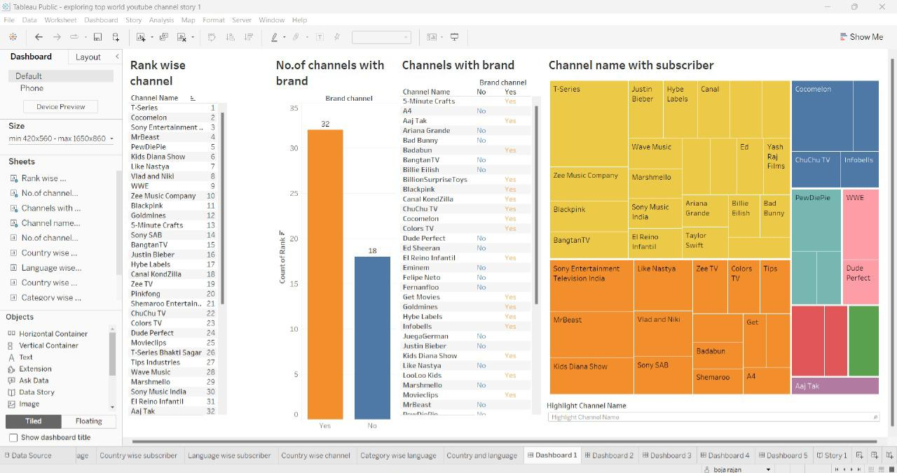

DASHBOARD 2:

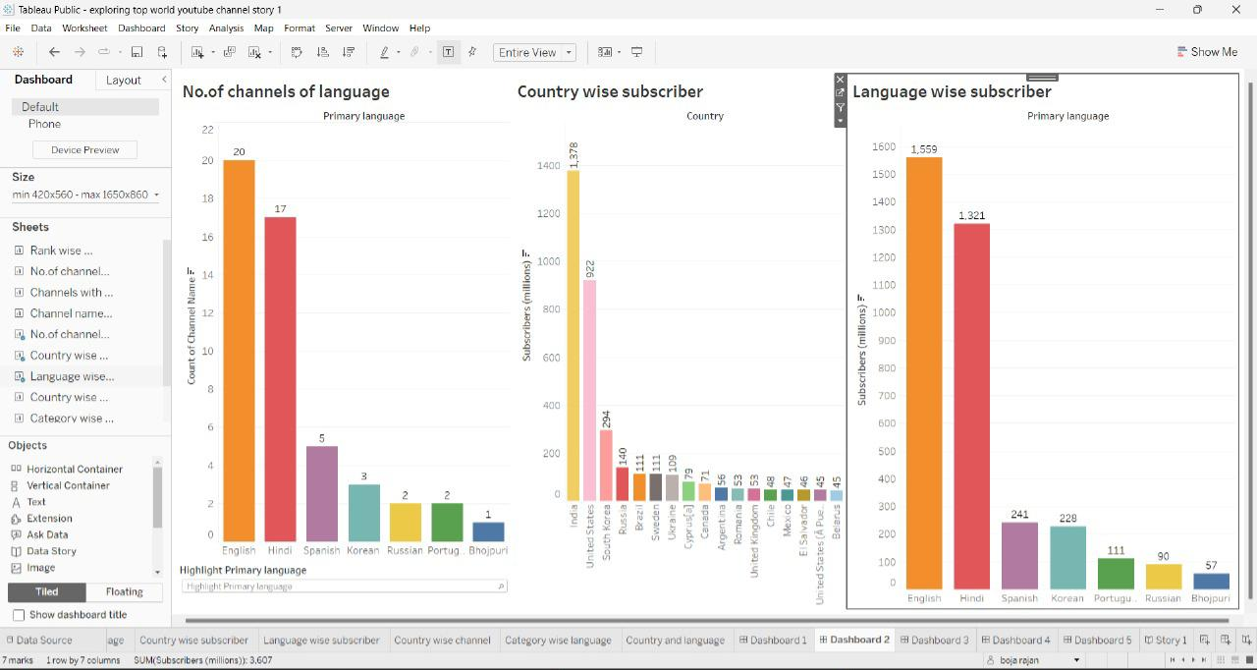

DASHBOARD 3: 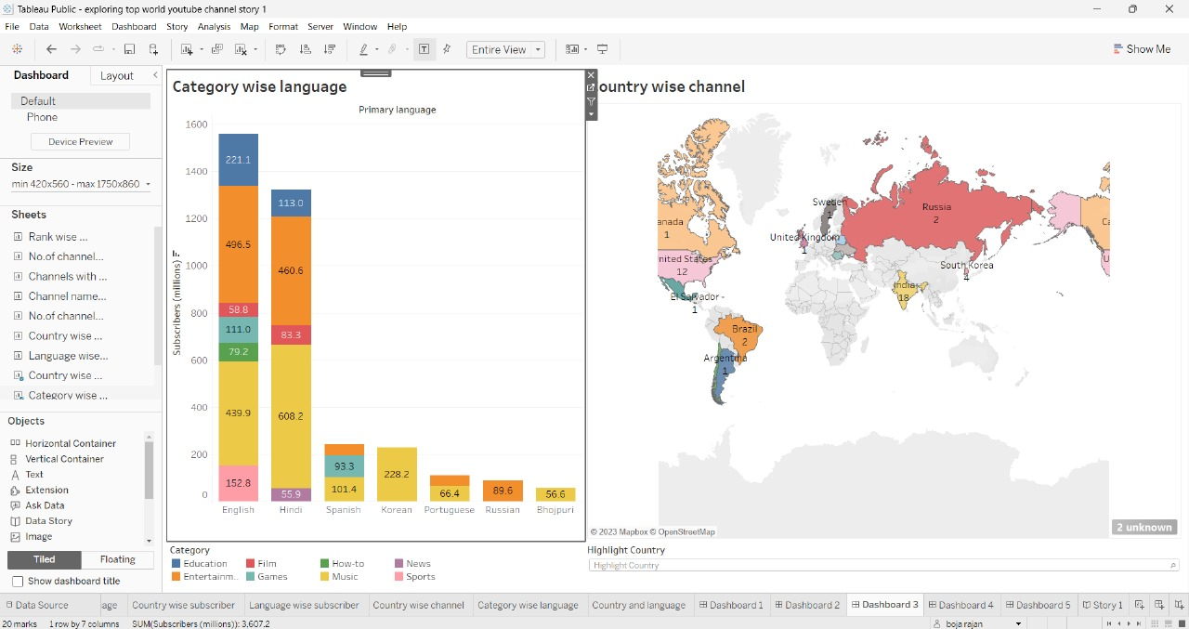

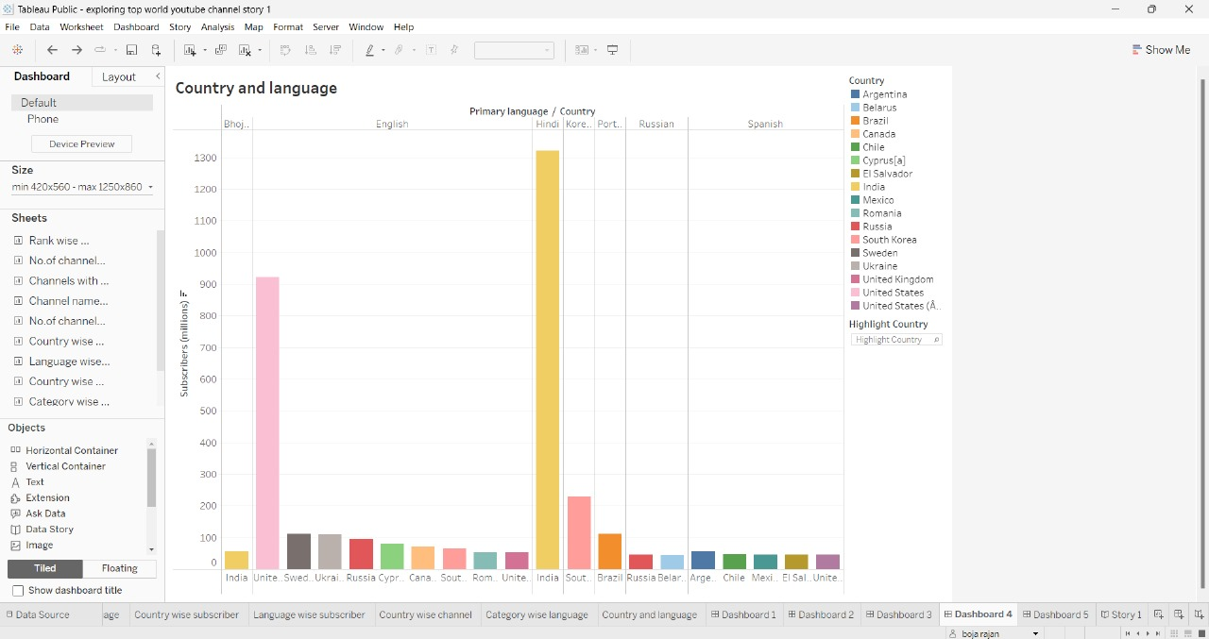DASHBOARD 4:

DASHBOARD 5:

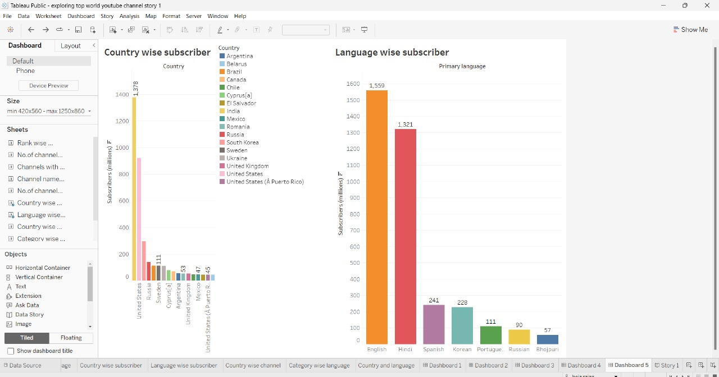

3)RESULT:

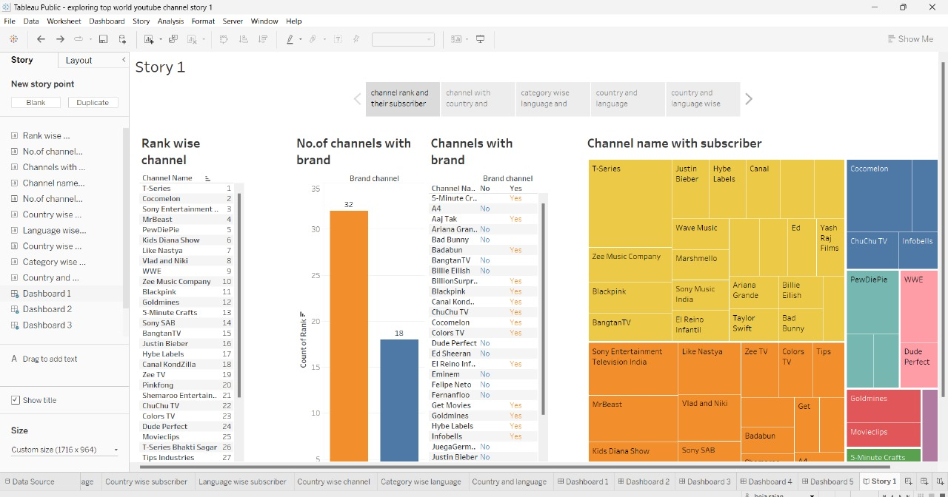

4)ADVANTAGE & DISADVANTAGE :

**Advantages**

**Content Inspiration**: You can discover popular content ideas and trends that resonate with a broad audience, helping you generate ideas for your own channel.

**Audience Insights**: Studying top channels can help you understand their demographics, interests, and behaviors, aiding in targeting your content to a specific audience.

**Monetization** Strategies: Learn how successful channels monetize through ads, sponsorships, merchandise, and more to optimize your revenue generation.

**Optimization Techniques**: Identify best practices for video titles, thumbnails, descriptions, and tags to improve your video's discoverability.

**Production Quality**: Analyzing top channels can help you understand the production quality standards necessary to attract and retain viewers.

**Engagement Strategies**: Observe how top channels engage with their audience, such as responding to comments and using community features.

**Platform Changes**: Stay updated on YouTube's algorithm updates and policy changes that could impact your channel's performance.

**Growth Strategies**: Discover the growth strategies used by top channels, such as collaborations, cross-promotions, and social media marketing.

**Competitor Analysis**: Analyzing top channels in your niche can provide insights into your competition and help you differentiate your content.

**Long-Term Success**: Understanding the factors contributing to the success of top channels can help you set long-term goals and build a sustainable YouTube presence.

DISADVANTAGE:

**Sample Bias**: Top channels may not represent the full range of content on YouTube, leading to a skewed understanding of the platform's diversity.

**Rapid Change**: YouTube trends and top channels change frequently, making analysis quickly outdated.

**Limited Generalizability**: Insights from top channels may not apply to smaller or niche channels, limiting the applicability of findings.

**Data Availability**: Access to data about top channels may be limited, making in-depth analysis challenging.

**Competition**: Attempting to replicate strategies of top channels may be difficult due to high competition and changing algorithms.

**Ethical Concerns**: Analyzing top channels can raise ethical concerns related to privacy, copyright, and content ownership.

**Biased Metrics**: Relying solely on subscriber count or view metrics may overlook channels with valuable content but fewer viewers.

**Resource-Intensive**: In-depth analysis of top channels requires significant time and resources.

**Limited Insights**: Focusing on the top channels may not provide insights into emerging or innovative content creators.

**One-Dimensional**: Analysis may focus too narrowly on popularity and overlook other aspects like creativity or educational value.

5)APPLICATION:

**TABLEAU AND GITHUB** used to apply the solution

6)CONCLUISON:

In conclusion, YouTube analytics is a valuable tool for creators to assess and refine their content strategy, improve engagement, and grow their channel. The specific conclusions you draw will depend on your goals and the data you've collected.

7)FUTURE SCOPE:

**Content Diversity**: YouTube is likely to see an even wider range of content, from educational and entertainment content to virtual reality experiences.

**Livestreaming**: Livestreaming is expected to grow, with more creators and organizations using YouTube for live events, gaming, and interactive content.

**Monetization**: YouTube may introduce new monetization options for creators and expand its advertising capabilities, allowing more creators to generate income.

**VR and AR Integration**: YouTube may further integrate virtual and augmented reality into its platform for immersive content experiences.

**International Expansion**: YouTube will continue expanding its global reach, potentially localizing content and features for specific regions.

**Regulation and Copyright**: YouTube will likely face continued challenges related to copyright and content regulation, which may shape its future policies and practices.

**AI and Recommendation**: YouTube’s recommendation algorithms will become more sophisticated, providing users with highly personalized content suggestions.

**Interactivity**: Enhanced interactive features may be introduced, allowing creators and viewers to engage in more meaningful ways.

**Mobile and Smart Devices:** YouTube will adapt to changing technology, potentially focusing more on mobile and smart device experiences.

**Social Integration**: YouTube may strengthen its integration with other social media platforms, making it easier for creators to share content and engage with their audiences.

Remember that these are speculative trends, and YouTube’s future will depend on technological advancements, market demands, and regulatory changes.